

**ETHEREUM BEHAVIORAL DESIGN PATTERNS – RANDOMNESS & ORACLES**

Date: 12/04/2018

Brent Anthony Tudas

Sandra Alleine Blanca

Jaymar Dingcong

Robert Aries Dela Paz

Kimberly Mae Reyes

Patrick Oliver Palmero

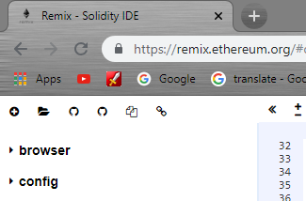**INSTRUCTIONS**

Go to <https://remix.ethereum.org/>

1. Click the icon and go to the folder

Directory of this document and select

RandomOraclizeQuery.sol

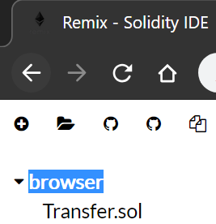

1. Click “browser” and it will collapse  
   find “RandomOraclizeQuery.sol” and select it.



1. 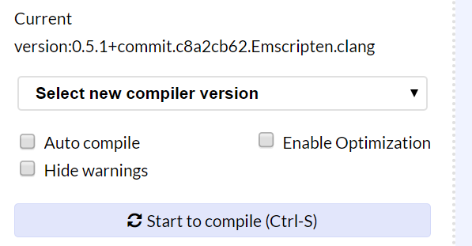Select new compiler version. Set it to 0.5.1+commit version and compile.

Then, select Run tab.

1. Select ***Environment*** change itto Injected Web3.
2. Select **Account** from the drop down button. Remember you chosen account.
3. 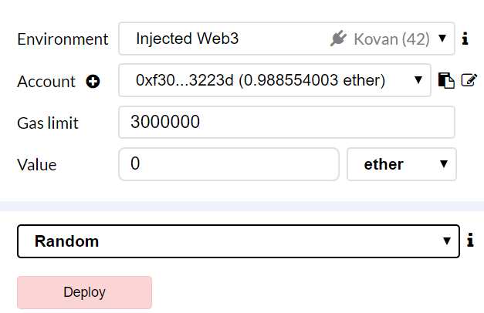 Click **deploy**.

**Contract Deployment**

Make sure you have metamask installed in your browser and have a test-net account with enough ethers to spare like so.

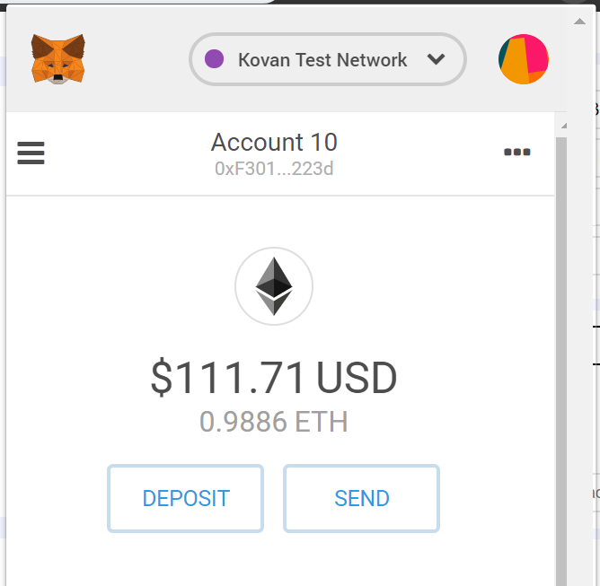

After clicking deploy you will see a pop up from Metamask like so. And just hit confirm.

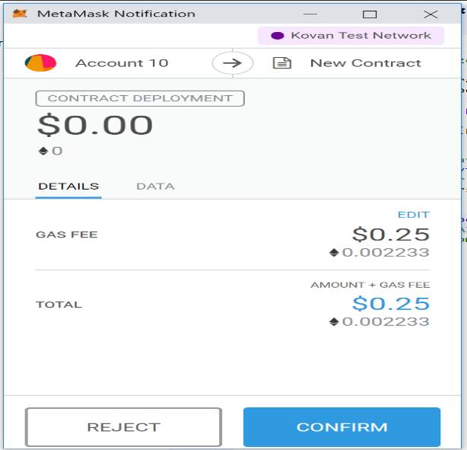

Wait for this transaction to appear on the lower portion of the remix screen. Then click the link highlighted. That link is the transaction details found in the test network, you will have to wait for some time for it to be approved.



Find this detail and click the highlighted hash to go to the deployed contract.



You should be able to see something like this.

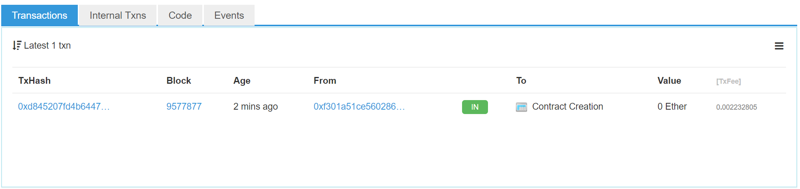

The table contains all the transactions occurring in the contract with thorough details like values of ether used. All the function calls you will do will result to transactions that you can see in this table.

**Getting a Random Number from Oraclize**

Find the getRandomNumber field and click it. There will be an upcoming metamask notification needing confirmation of your transaction.



It should look something like this. Then click confirm and you for the transaction to be approved.

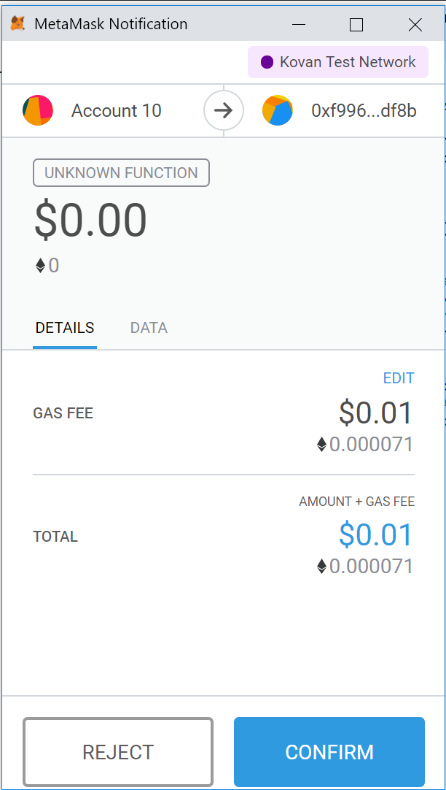

Notice the table updated from the latest transaction. And click the latest transaction to get more details.

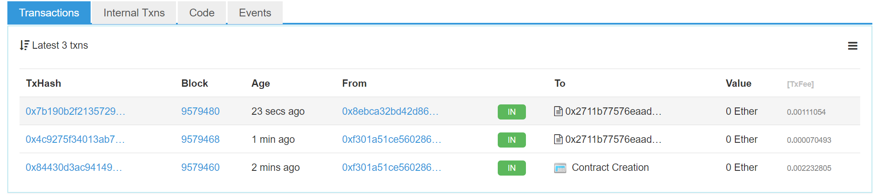

The __callback function is now called. Setting the random number to be equal to the random number from the external python script. Get the first hash to get more details.

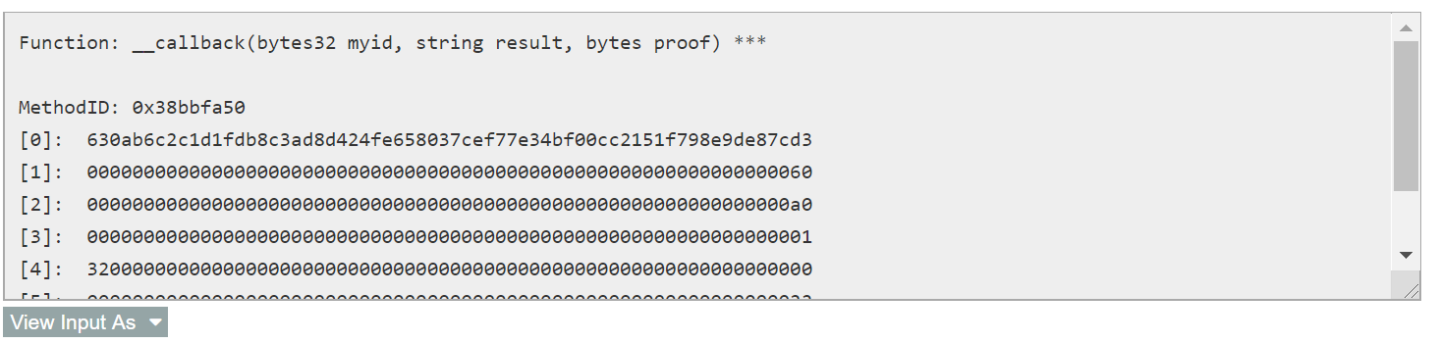

Go to <http://app.oraclize.it/home/check_query>. Then enter the first return hash from the callback function to get the result of the query.



You should have something like this. Note that the result will be different since it’s a random number.

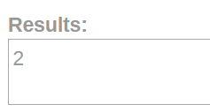

Then go back to remix and confirm that the result is indeed the random number in the contract.

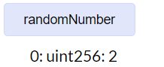

And you’re done.

**References:**

**Oraclize Documentation -**

[**http://www.oraclize.it//**](http://www.oraclize.it//)

**Oraclize Query Checker –**

[**http://app.oraclize.it/home/check_query**](http://app.oraclize.it/home/check_query)

**Kovan Test Network –**

[**https://kovan.etherscan.io/**](https://kovan.etherscan.io/)

**Kovan Test Network Faucet –**

[**https://faucet.kovan.network/**](https://faucet.kovan.network/)